**Children’s Therapy Services**

# L.A.R.C.

Constraint- Induced Movement Therapy

Intensive

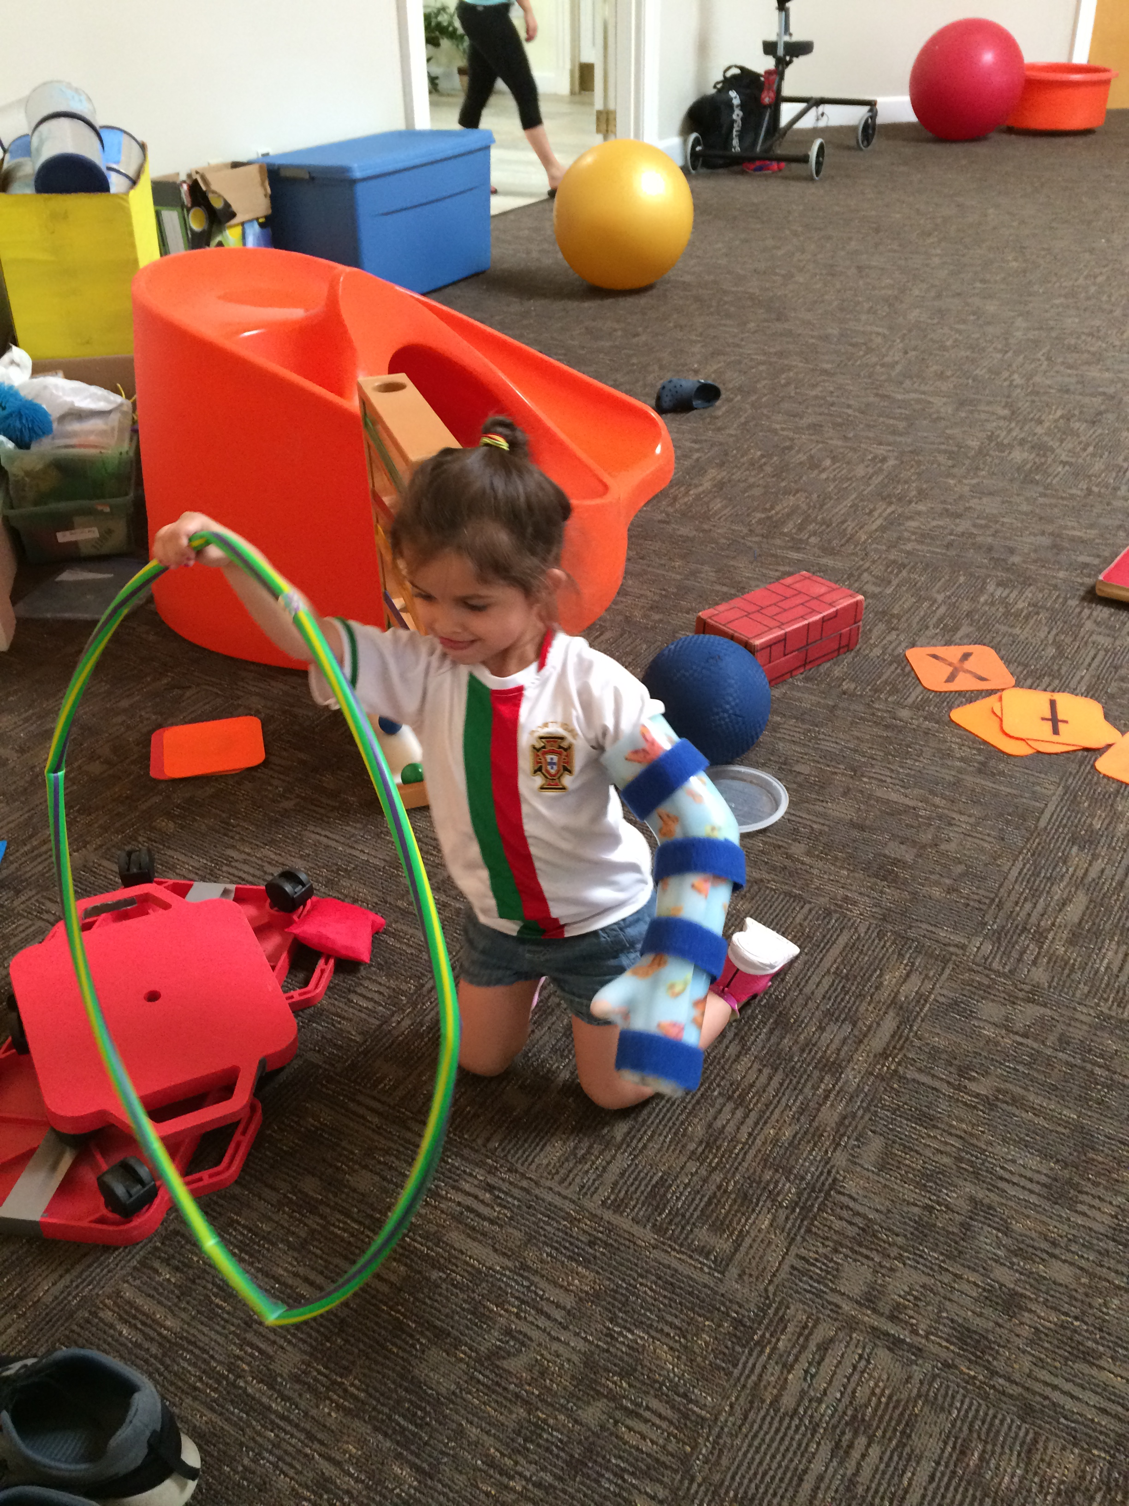

Phone: 203.271.3288

Website:childrenstherapyservices.org

E-mail address: Jackcts01@yahoo.com

# Please join us for this Fun-filled Camp-Therapy experience!

**2017 DATES AND TIMES:**

One 3-week camp session, June 26-July 14

Monday-Friday, 9:00am - 3:00pm

At Chase Collegiate Campus Waterbury, CT

References

(2013). A Handbook of Pediatric Constraint-Induced Movement Therapy (P-CIMT): Principles of Precision Practice. In: Ramey SL, Coker-Bolt P, DeLuca SC (Ed.), . Bethesda, MD: The American Occupational Therapy Association.

DeLuca SC, Case-Smith J, Stevenson R, Ramey SL. (2012). [Constraint-induced movement therapy (CIMT) for young children with cerebral palsy: Effects of therapeutic dosage.](http://www.ncbi.nlm.nih.gov/pubmed/22699104) Journal of Pediatric Rehabilitation Medicine 5, 133-42.

DeLuca, S. C., Echols, K., Ramey, S.L. (2007) ACQUIREc Therapy: A Training Manual for Effective Application of Pediatric Constraint-Induced Movement Therapy, MindNurture, Hillsborough, NC.

Huang, H., Fetters, L., Hale, J., McBride A., (2009) Bound for Success: A Systematic Review of Constraint-Induced Movement Therapy in Children with Cerebral Palsy Supports Improved Arm and Hand Use. Physical Therapy 89:1126-1141

# L.A.R.C.

# Lefty and Righty of CT Constraint-Induced Movement Therapy

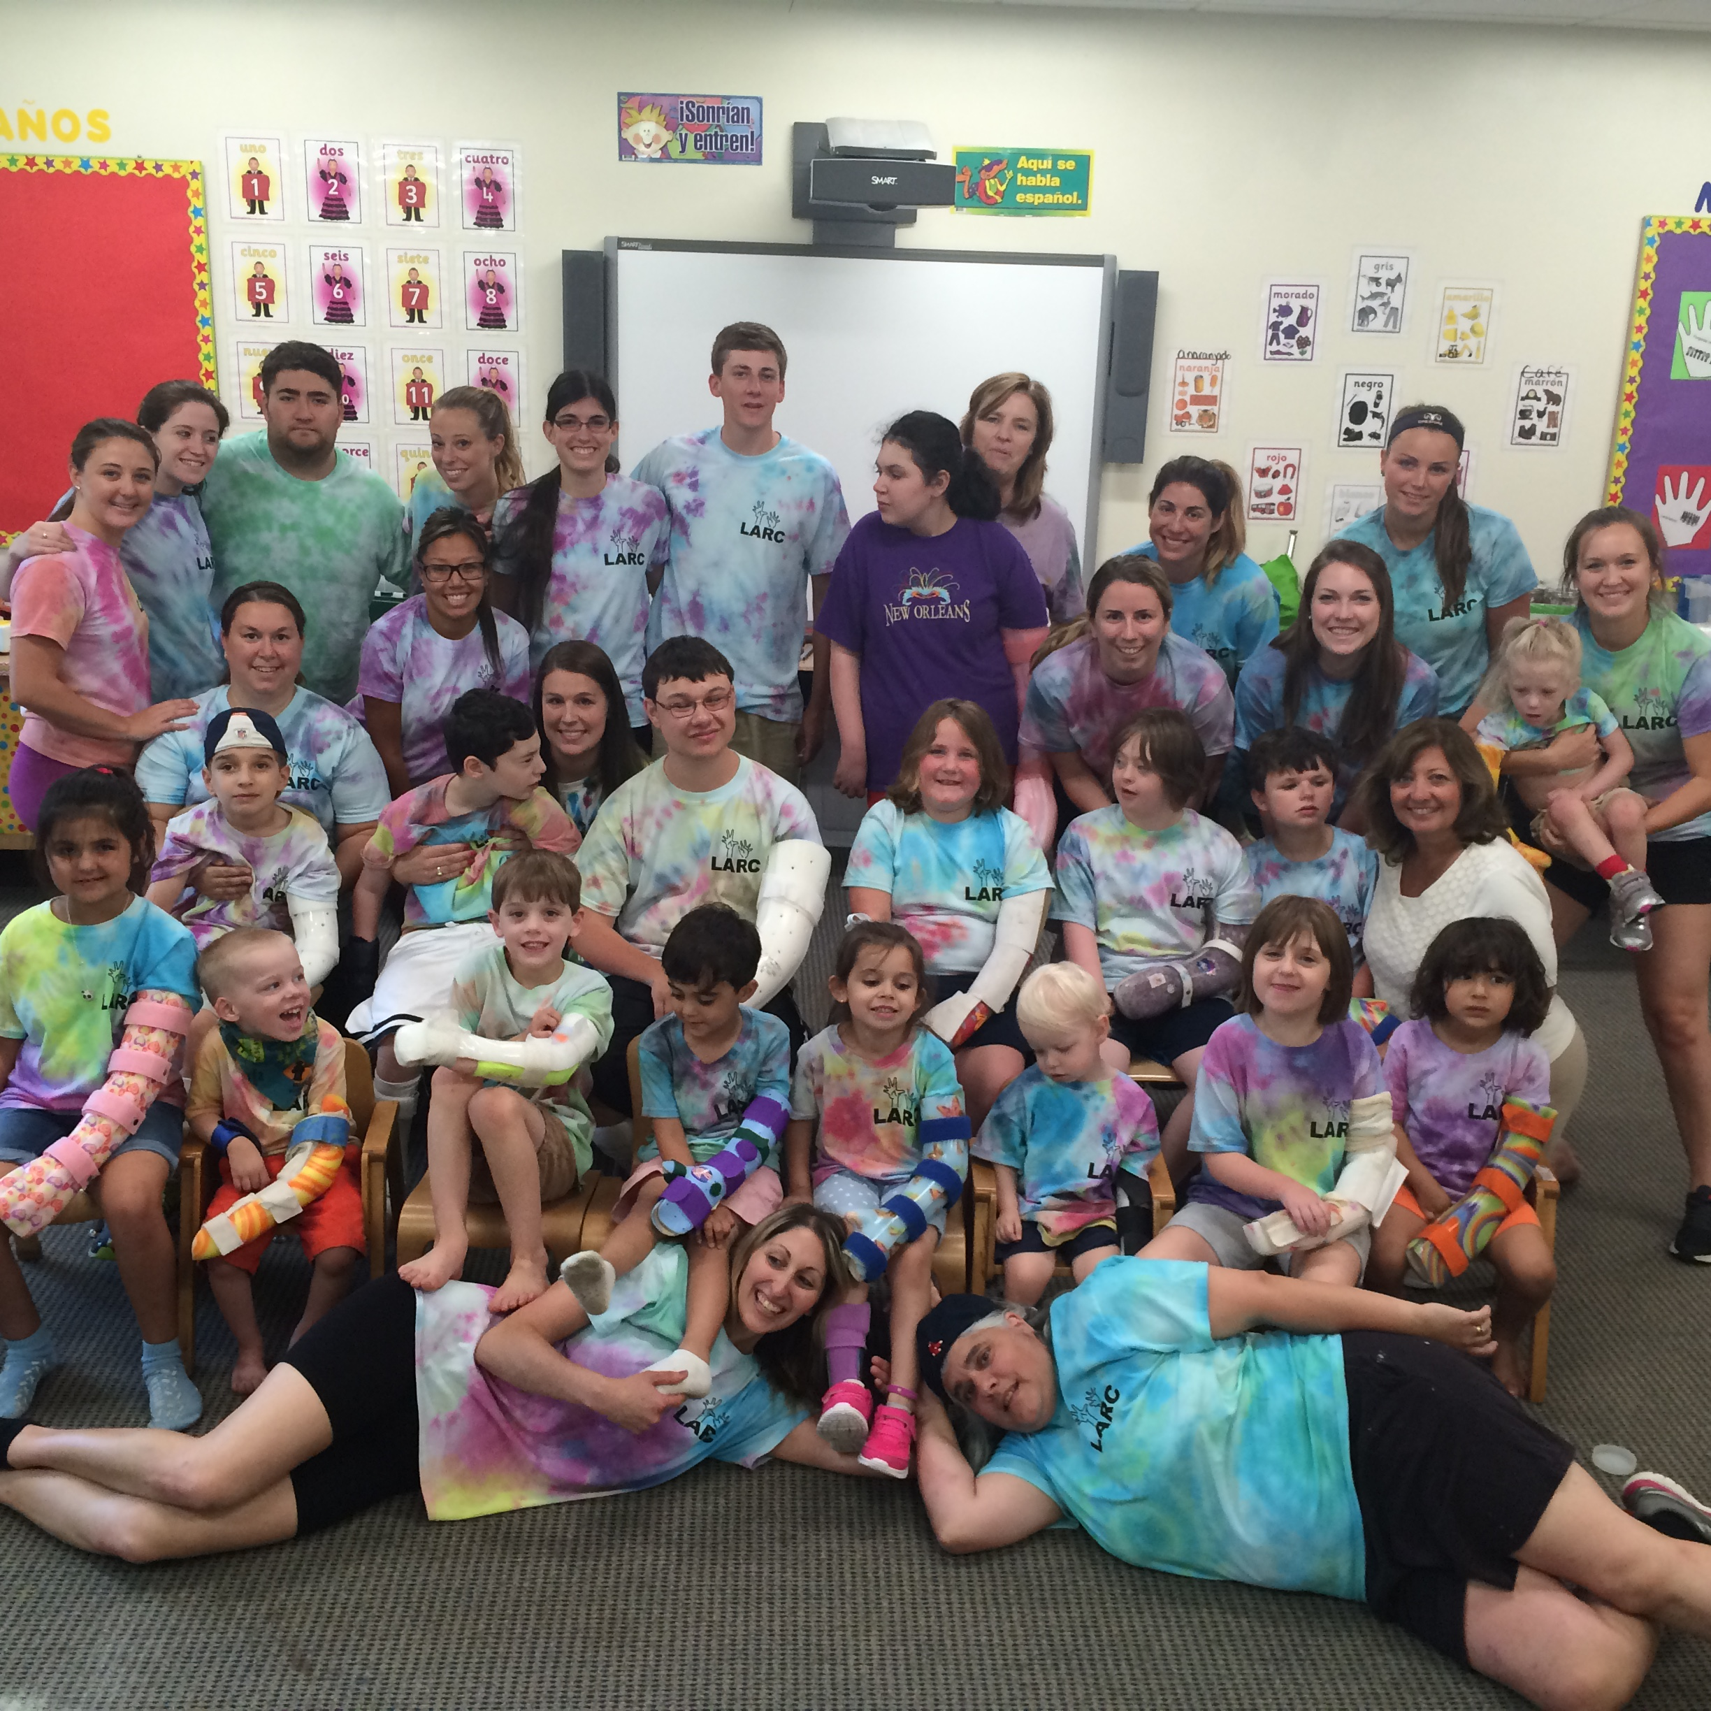

# A Fun Full Day Therapy Program for children with hemiplegia due to:

# Cerebral Palsy

# Stroke

# Traumatic Brain Injury

# Other Neurological Conditions

**Children’s Therapy Services**

#### L.A.R.C.

Phone: 203.271.3288

Email: Jackcts01@yahoo.com

"My son was so excited to go to camp each morning and made unbelievable progress! The therapists are wonderful"

mother of

# What is LARC?

This camp-like program was established in 2006 to provide an effective and intensive intervention method for children with hemiplegia. Constraint-Induced (CI) Movement Therapy is an intensive treatment approach for children with decreased use of one upper extremity due to hemiplegia. It involves “constraining” the child’s UNAFFECTED (or less affected) arm, using a removable cast. This creates an environment for the child to use their AFFECTED arm in a variety of FUN and therapeutic activities under the guidance of experienced pediatric therapists. The Protocol for Constraint-Induced Movement Therapy known as ACQUIREc Therapy is utilized.

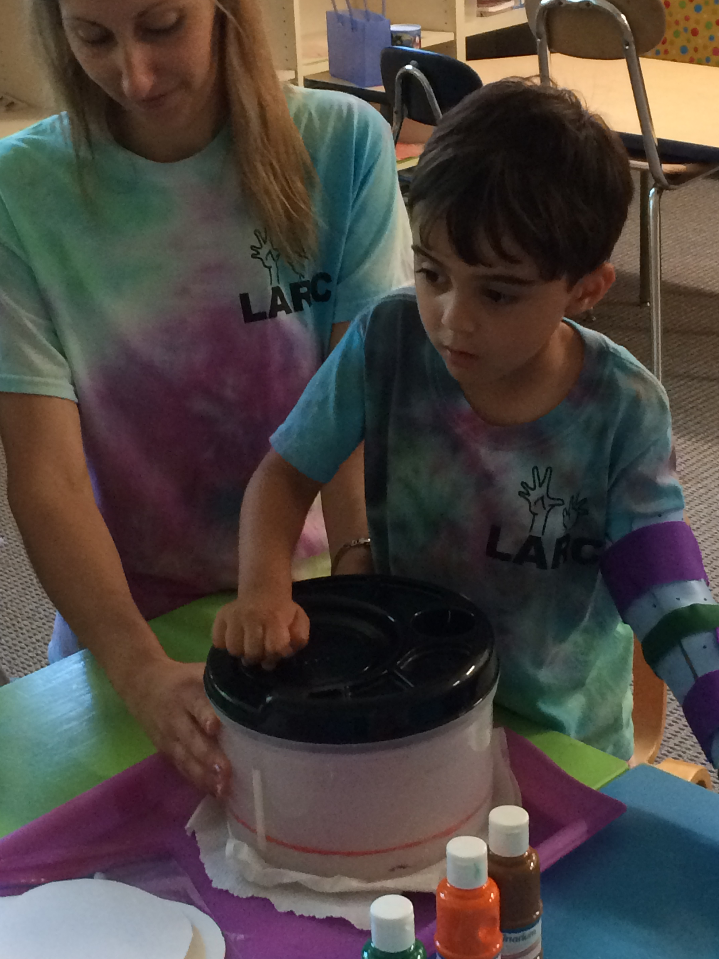

LARC developed a program that provides intensive CI therapy in a FUN, camp-like environment. Your child will wear their cast while participating in specific activities targeted to increase your child’s use of their affected arm. The activities used are designed to facilitate and refine voluntary control of the involved arm and hand and encourage use of the arm/hand for activities of daily living such as eating and dressing.

# Who is eligible for the program?

Any child with a neuromotor disability resulting in one arm/hand being significantly weaker than the other. The child must be medically stable. The child must be at least 3 years of age to participate in the full 6 hour program. A modified program for children under the age of three is available Children who have attended the camp in the past have had a variety of Neuromotor Disorders such as hemispherectomy, hydrocephaly, stroke, cerebral palsy and acquired brain injury

# How long is the program?

# Six hours a day for three weeks (no weekends) Parents provide lunch for their child. Snacks will be provided.

# Who is the staff?

Children’s Therapy Services experienced pediatric occupational therapists and physical therapists work directly with the children. PT and OT students from area universities are also involved. Certified Special Education teachers direct the group activities. Volunteers also assist to help maintain a fun camp-like atmosphere.

# What is the cost?

The three week constraint induced movement therapy program fee is $3300.00. Cast fabrication by an orthotist in your area is an additional fee. We require all competed forms and a $500.00 deposit by April 1st.The remaining balance is required prior to first day of camp unless other arrangements have been made We assist you in obtaining medical insurance coverage.

# How is the program designed for each child?

An initial interview is conducted to determine appropriateness for the intervention. The Initial assessment includes the Assisting Hand Assessment which is a tool designed to measure how a child uses his/her affected hand (assisting hand) collaboratively with the non-affected hand during bimanual play. Individualized goals, specific to each child and family, are established based on the assessment and progress. Data is taken daily on several tasks to measure changes in functional use of the upper extremity. The program incorporates activities, based on these goals that will be challenging, but achievable to ensure that each child has success, and most importantly has FUN! The ultimate goal is for each child is to use both arms together for everyday activities!

#### L.A.R.C.